High Efficient Thickener
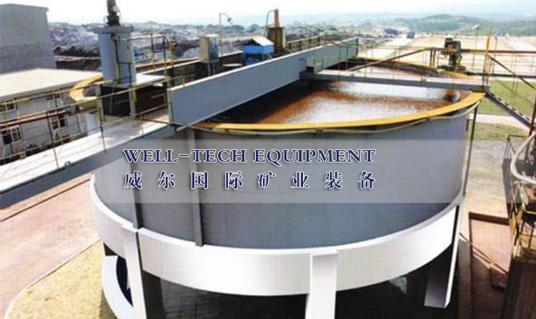

Brief Introduction
The type of GX high-efficiency thickener is semihigh efficiency without folcculating agent added. Compared with common thickener, it has the following structure features:
- Long intermediate receiving barrel; a large diameter receiving tray arranged at the bottom; uniform, stable and smooth feeding.
- A venting storage tank is arranged for eliminating air bubbles in the ore pulp, which has a large processing capacity and increases underflow concentration.

Remark
- The performance is better than the common thickener, when it is used without flocculating agent
- Flocculating agent adding device requires a separate order

Main Technical Parameters

Model | Inner Diameter of tank  (mm) | Height of tank  (mm) | Sedimental area  (mm) | Revolution of the rabble  (r/min) | Lifting height of the rabble  (mm) | Driving motor model | Driving motor power  (kw) | Lifting motor model | Lifting motor power  (kw)
GX-3.6 | 3600 | 1700 | 10.2 | 1.1 | 200 | Y100L-6 | 1.5 | PZ0.8AB | 0.8
GX-5.18 | 5182 | 2134 | 21 | 0.8 | 300 | Y132M1-6 | 4 | PZ0.8AB | 0.8
GX-7.5 | 7500 | 2800 | 44.1 | 0.427 | 300 | Y132M2-6 | 5.5 | Y132S-8 | 2.2
GX-9 | 9000 | 2800 | 63.6 | 0.427 | 300 | Y132M2-6 | 5.5 | Y132S-8 | 2.2
GX-12 | 12000 | 3600 | 110 | 0.35 | 300 | Y132M-4 | 7.5 | Y100L1-4 | 2.2
GX-15 | 15000 | 4000 | 177 | 0.15 | 300 | YCT200-4B | 7.5 | Y112M-6 | 2.2
GX-18 | 18000 | 4400 | 254 | 0.13 | 400 | YCT200-4B | 7.5 | YCT200-4A | 5.5
GX-20 | 20000 | 4400 | 314 | 0.13 | 400 | YCT200-4B | 7.5 | YCT200-4A | 5.5

